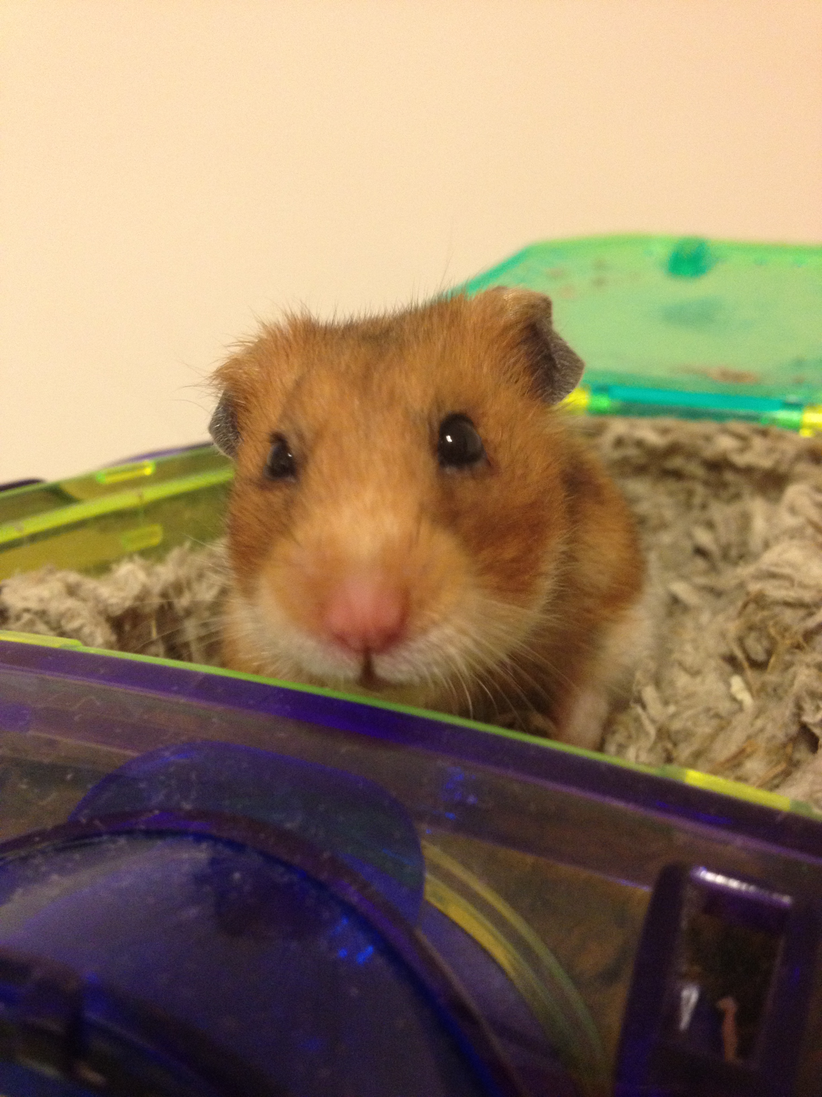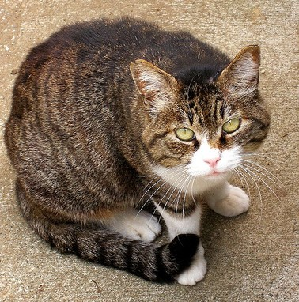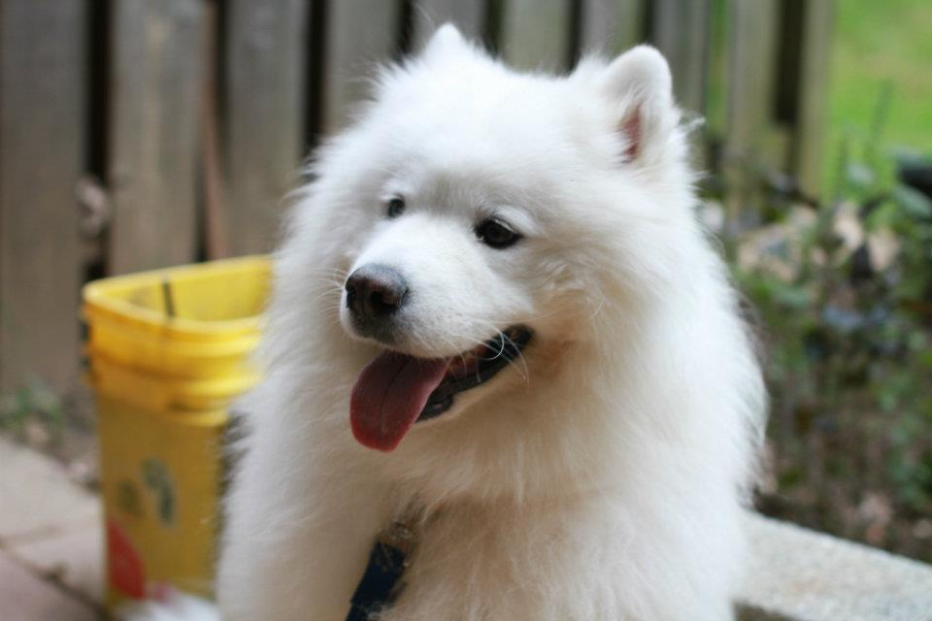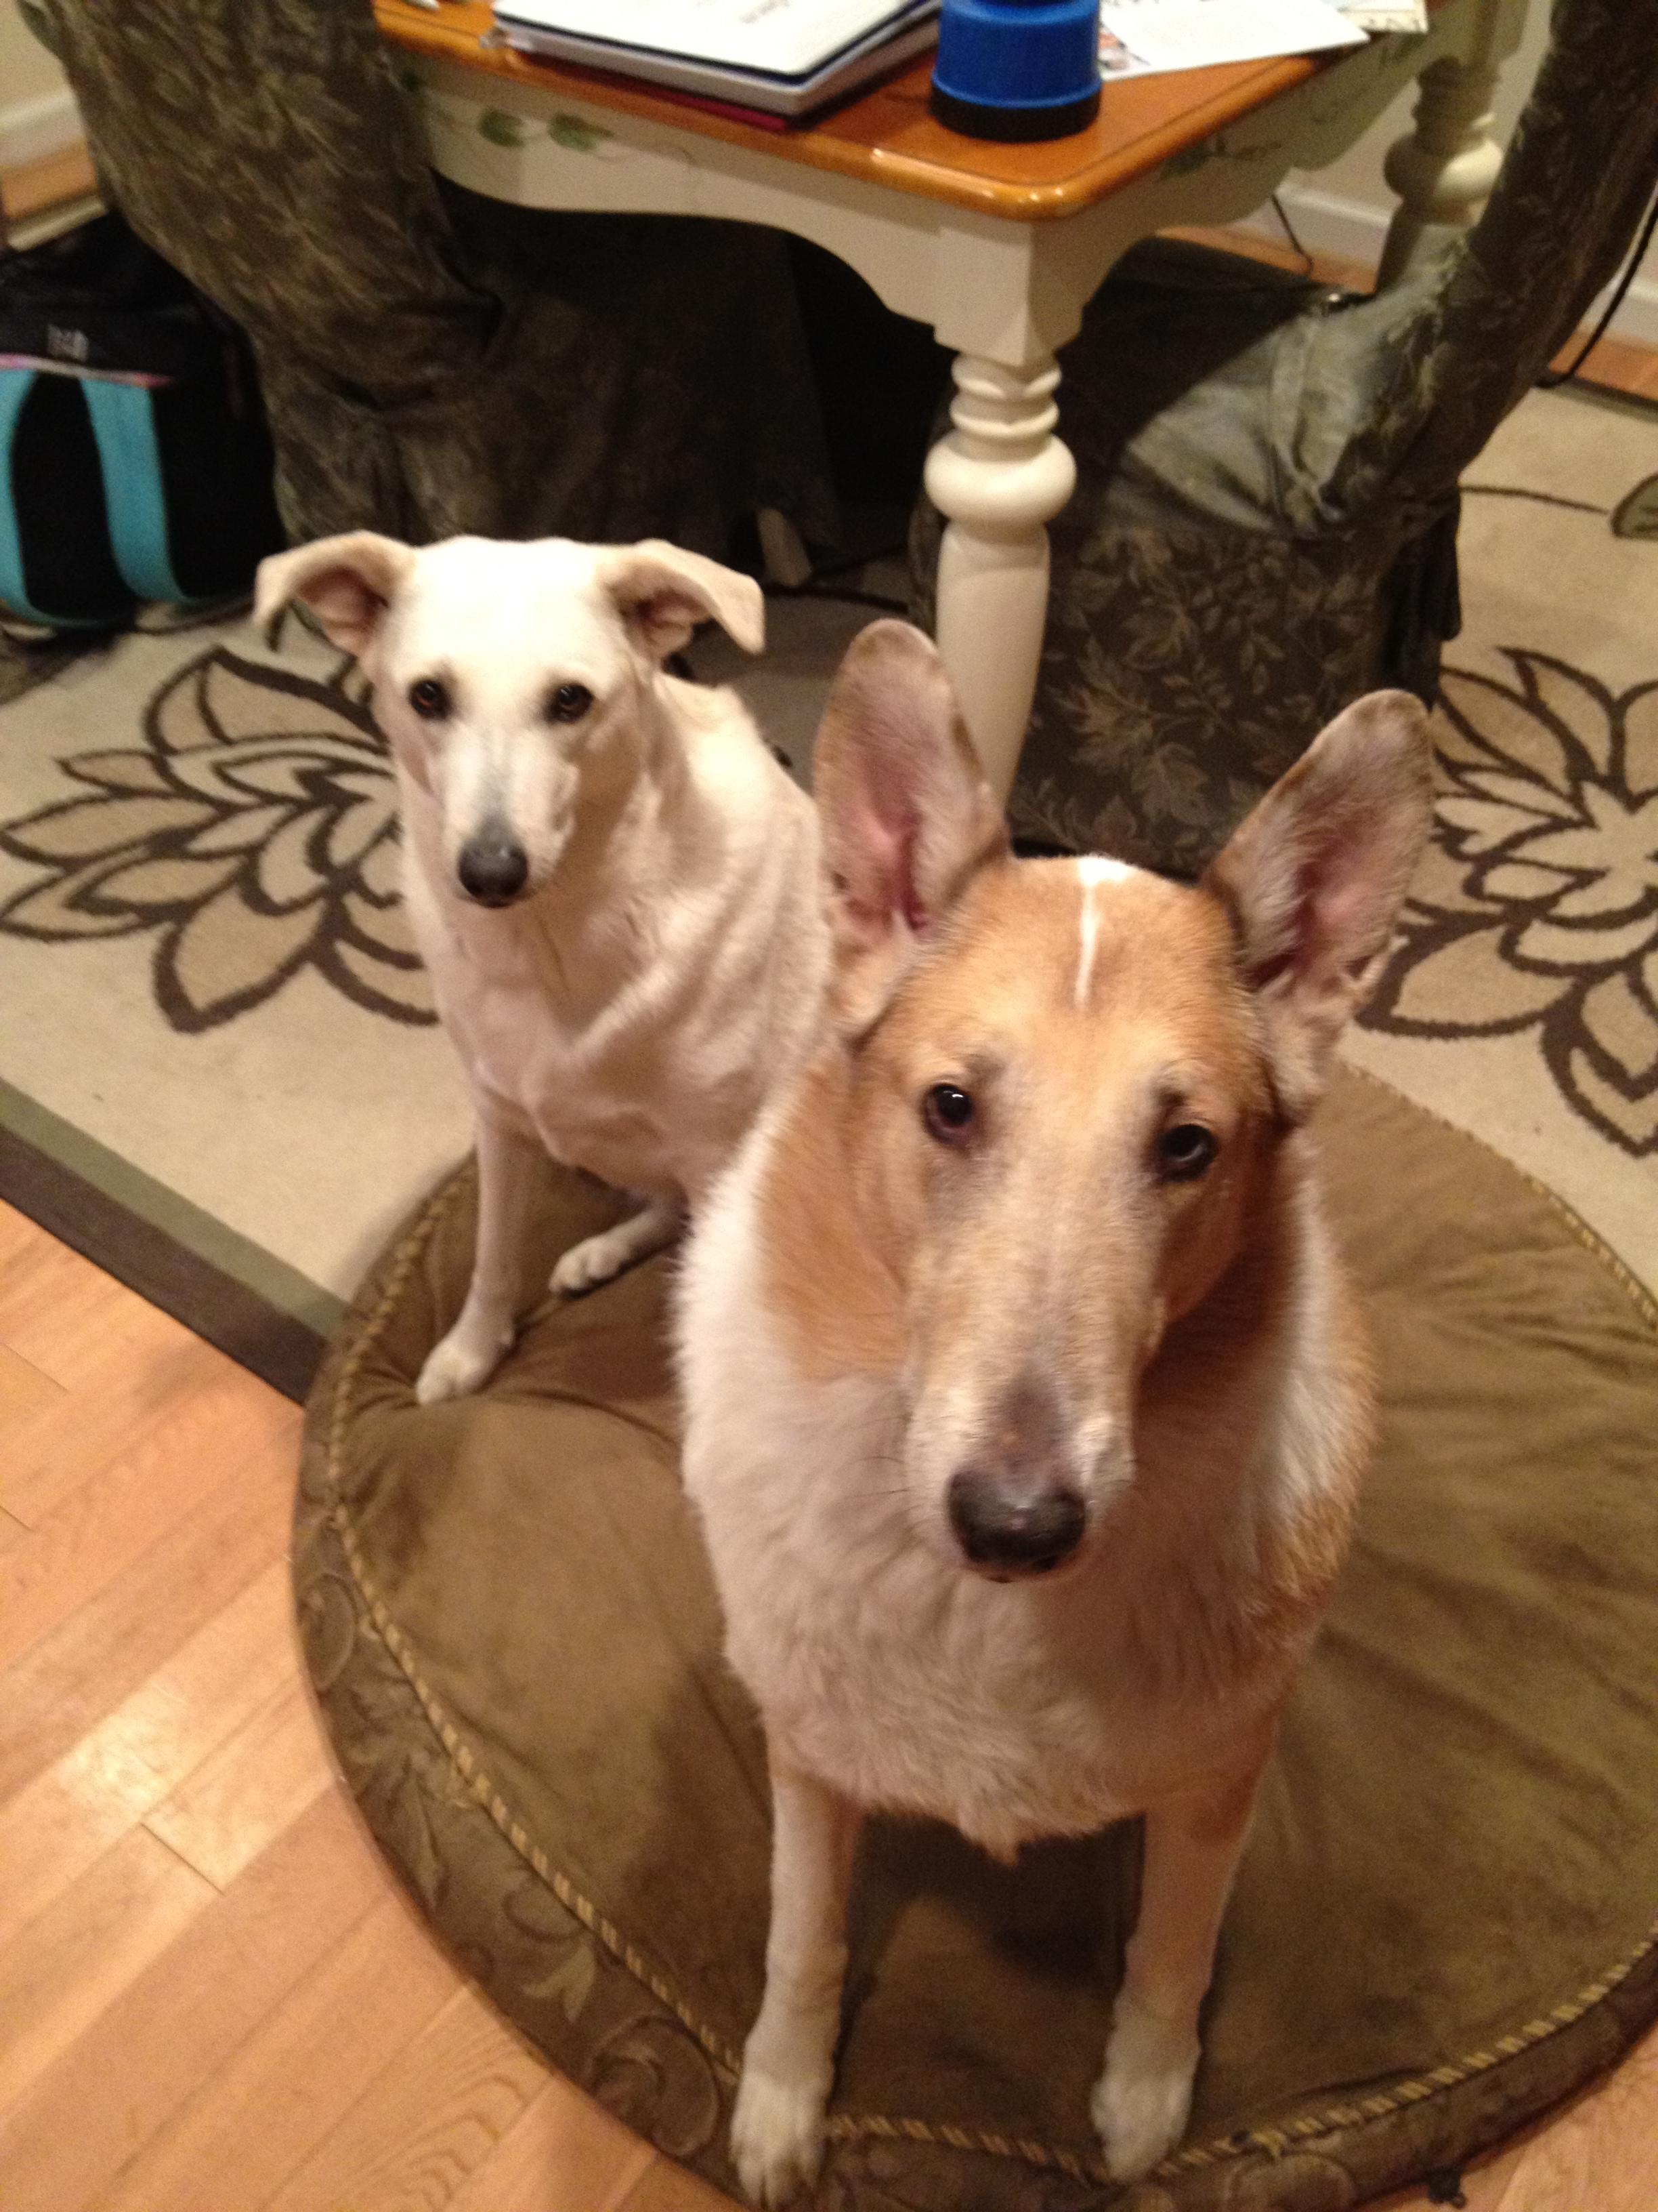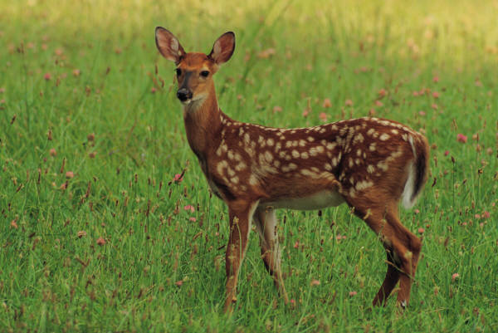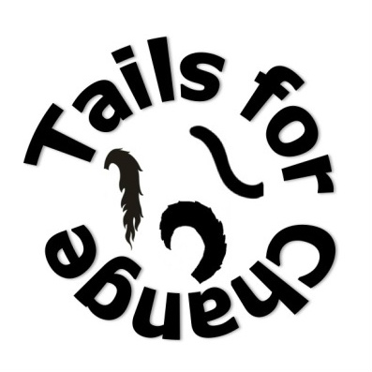

We believe all animals have the right to a healthy and happy life.

# Please visit our website for more information:

# tailsforchange.weebly.com

# *Take a chance, make a change, save a life.*

Tails for Change is a program designed to bring high school students together to educate them on animal abuse/rights and together help improve the lives of animals through our outreach efforts.

At our meetings, we discuss current issues in animal welfare, analyzing the various aspects of the situation as well as developing practical solutions. We provide guest speakers for our members from various facets of the animal welfare world. On a monthly basis, we volunteer at various animal welfare organizations and fundraiser for these same organizations throughout the year. On a biannual basis, hold informational events for the community around Richard Montgomery as well as students to inform them on pressing issues, what they can do, as well as providing guest speakers.

We are starting small but we dream big. We dream of a world in which animals are not mistreated and their value is recognized by all people. So help us and take a stand against animal cruelty.

Tails for Change